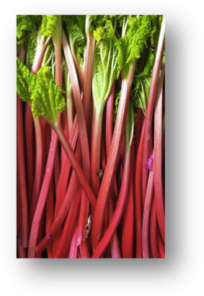May Edition - Rhubarb
by Gisele Gaffney, Chelsea Community Gardener

How to Grow

Technically a vegetable, rhubarb or “pie plant” can keep growing for 20 or more years, and will reach two feet high and six feet wide. To allow enough space for the mature plant, dig a hole two feet around and at least one foot deep. Add compost and plant “crowns” (the tops of the plant) three feet apart at a depth of 2-3 inches below the soil surface. Water and cover with a layer of mulch.

When to Harvest

A mature rhubarb plant can produce up to six pounds of stalks each season. For the first two years after planting, take only a few stems at a time and only for a few weeks throughout the season. In the third growing season, harvest as much as you want from spring through the first part of July or until stalks begin to appear smaller in diameter.

In Season
April, May, June and July

Fun Facts

- Rhubarb, which is technically a vegetable, was declared to be a fruit for the purpose of regulation and duties by a New York court in 1947 – taxes were higher for vegetables than fruit.
- In traditional Chinese medicine, rhubarb has been used as a laxative for thousands of years.
- The Russians took some rhubarb to Alaska in the 1800’s because they thought it would protect people from scurvy.
- Rhubarb’s green leaves are toxic, but its stalks are edible.
- Generally rhubarb’s stalks are tart, but the redder the stalk, the sweeter the taste.
- In 2014, Chelsea Community Gardeners won a Blue Ribbon at the Topsfield Fair for the Strawberry-rhubarb jam they prepared during Chelsea Community Garden's Year of the Fruit Canning Workshop held at Chelsea's Jordan Boys and Girls Club.

Nutritional Value

The stems offer multiple vitamins and minerals. The green leaves should be avoided because they are toxic. Rhubarb is a good source of fiber to support the digestive system, and it is also rich in phytochemicals. Likewise, rhubarb is packed with vitamin C and calcium, and is very low in sugar, fats and sodium. One serving of plain rhubarb, or ½ cup, has 15 calories.

Recipes

Although rhubarb stalks are tart, a bit of sugar and heat easily mellow its strong sour flavor, and it is the perfect fit for both savory and sweet dishes. For many years, rhubarb has been paired with strawberries in its most famous form as a strawberry rhubarb pie! Cooks today are finding other culinary uses for this reddish colored, crisp, tart ingredient, and rhubarb is making its way into jams, soups, salsas, and stews.

Chicken Rhubarb Entrée

Original recipe is from chow.com, and it can be viewed at:
http://www.chow.com/recipes/28384-rhubarb-braised-chicken-thighs
- 2 skinless chicken breast halves (trim excess fat). Cut in ½” thick slices, about 10-12 pieces depending on the size of the breast.
- 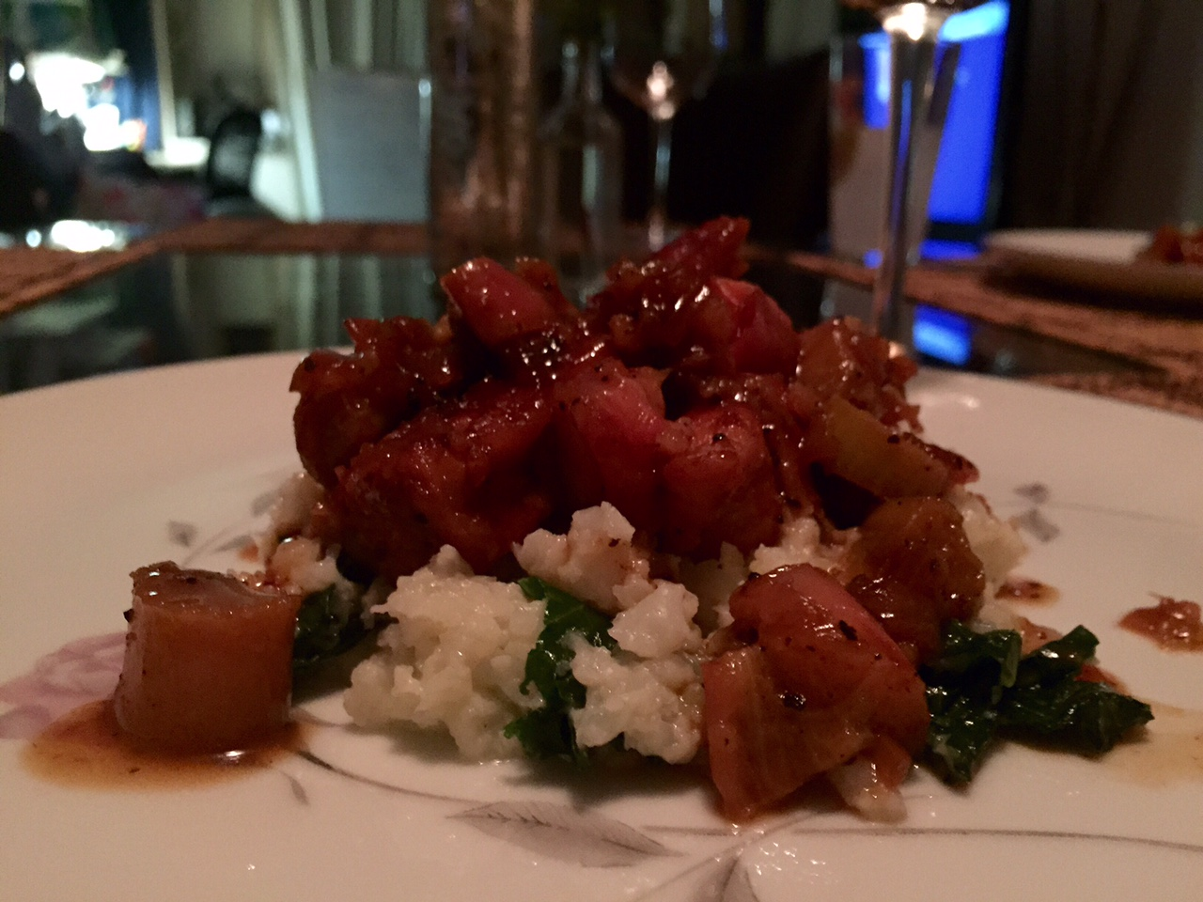Kosher salt
- Freshly ground black pepper
- 2 tablespoons olive oil
- 2 medium shallots, finely chopped
- 1 tablespoon finely chopped fresh ginger
- 1 teaspoon ground cardamom (optional)
- 1/2 cup dry sherry
- 1/2 cup low-sodium chicken stock
- 3 tablespoons of honey
- 1/4 cup freshly squeezed orange juice (from about 1 medium orange)
- 1 tablespoon of butter to finish the sauce
- 1 pound rhubarb, medium diced (3-4 stalks or 2 cups)

Instructions
- Heat 1 tablespoon of oil in a large, heavy-bottomed pot or skillet over medium-high heat until shiny. Reduce to medium heat, place half of the chicken fillets in the pot, and cook until golden brown, about 5 minutes. Turn over and cook the second side until golden brown, turning constantly to brown both sides, about 4 minutes more. Transfer the pieces to a plate and repeat with the remaining chicken.
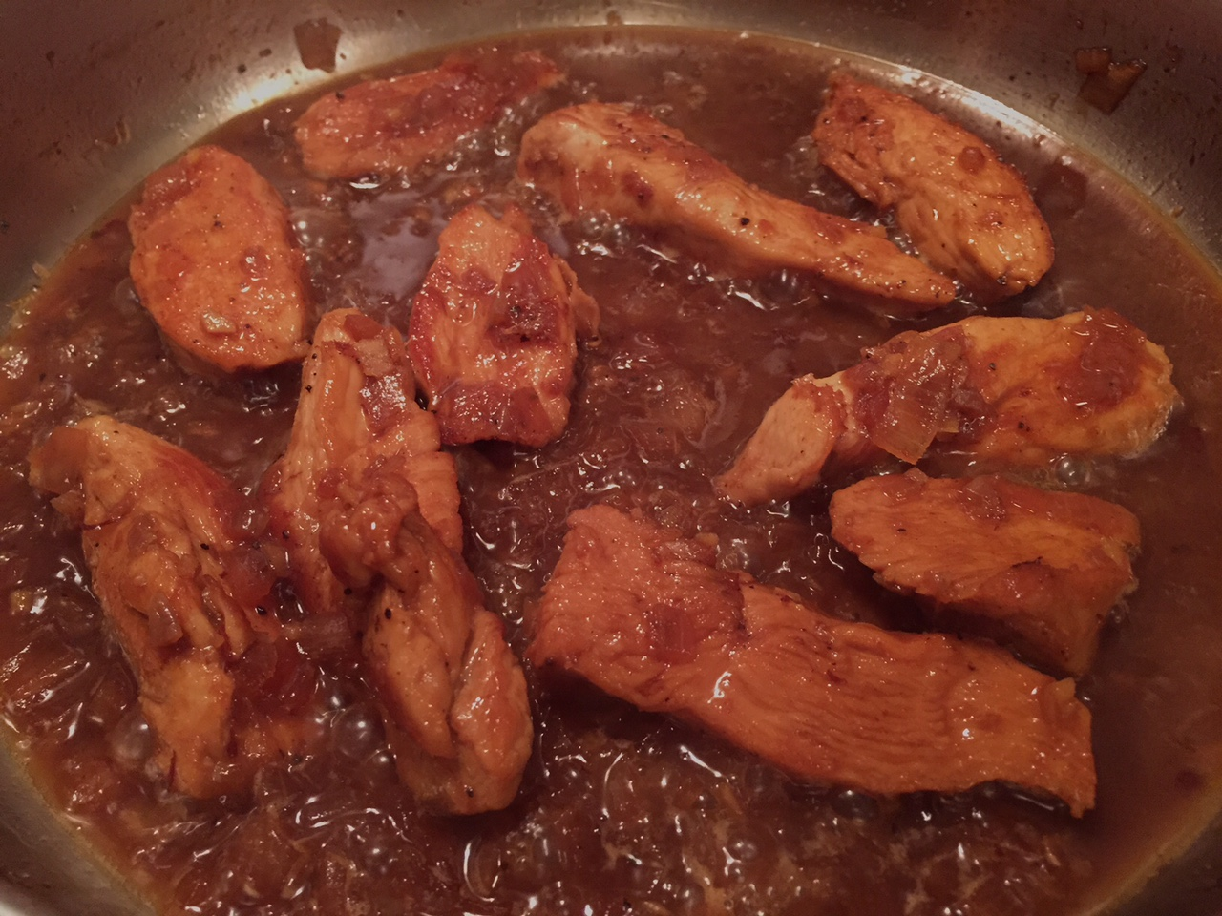
- Reduce the heat to medium and add the other tablespoon of oil, the shallots, ginger, and cardamom. Season with salt and pepper, and sauté until the shallots soften, about 2 minutes. Pour in the sherry, scraping the bottom of the pot to release any browned bits, and reduce the liquid by half, about 3 to 4 minutes. Add the chicken stock, honey, and orange juice and stir to combine. Return the chicken pieces and any accumulated juices to the pot, turn the chicken to coat, and bring the mixture to a boil.

- Reduce to a medium heat, and cook covered until the sauce is vigorously bubbling and it has reduced about a third (about 15 -20 minutes). Next, add 1 tablespoon of butter and cook it for about a minute. Next, add the rhubarb pieces between and around the chicken, and continue to cook until the rhubarb is can be easily cut with a knife, about 5 minutes.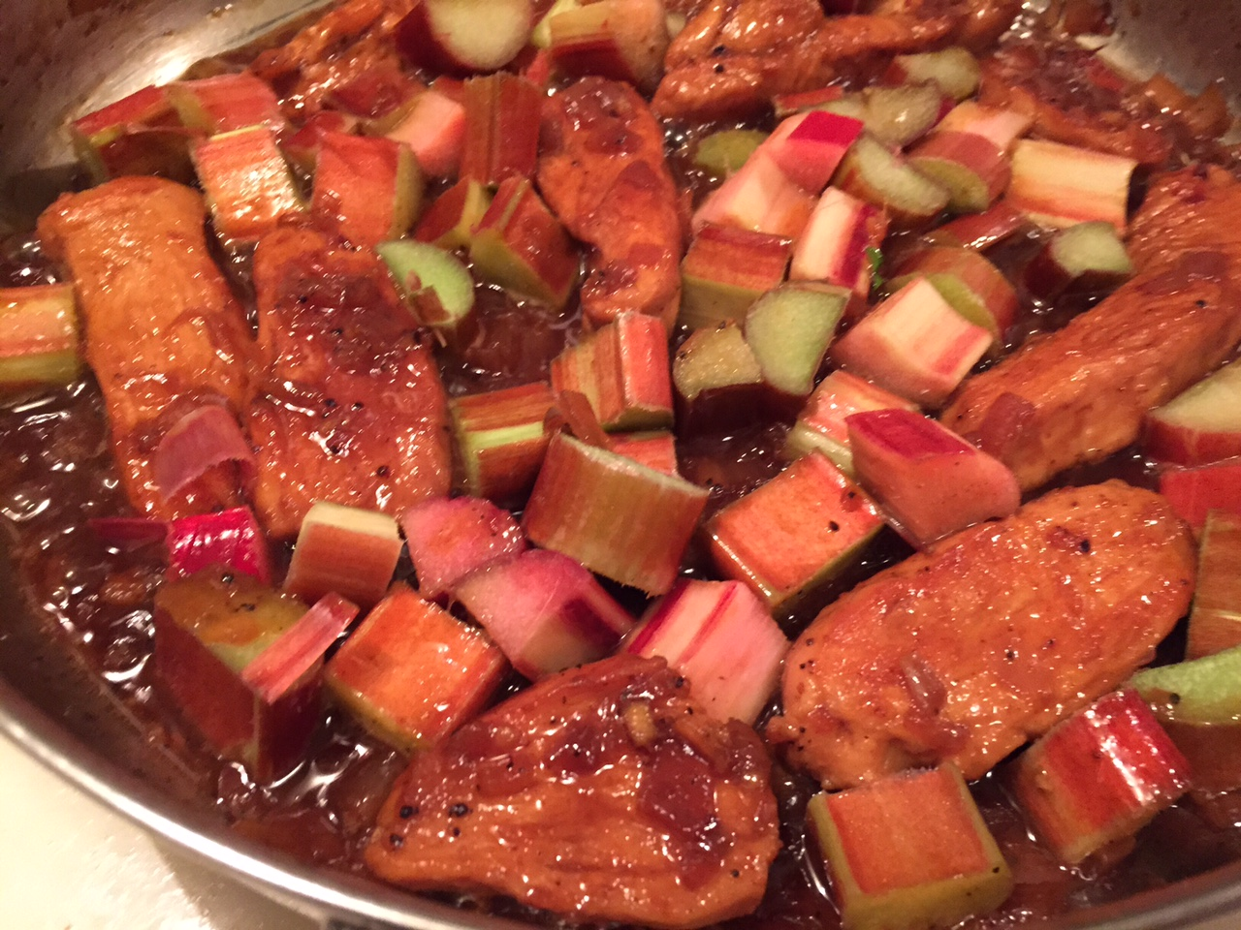
Rhubarb & Strawberry Oat Crunch Dessert

The original recipe is from allrecipes.com, and it can be viewed at: http://allrecipes.com/recipe/low-sugar-strawberry-rhubarb-crunch
- 4 cups chopped fresh rhubarb
- 1 pint strawberries, hulled and sliced
- 1 tablespoon honey
- 1 cup of rolled oats
- 2 tablespoons of chia or flaxseeds
- ½ cup of packed brown sugar
- 3 tablespoons of butter
- 1 teaspoon of ground cinnamon

Instructions
- Preheat the oven to 350°F (175°C)
- In a medium bowl stir together the rhubarb, strawberries, and honey. Transfer to a shallow baking dish. In the same bowl, stir together the oats, chia or flaxseeds, brown sugar and cinnamon. Mix in the butter until crumbly, and spread over the top of the fruit.
- Bake 40 minutes in the preheated oven, until rhubarb is tender and the topping is toasted. Serve warm.
Information Courtesy of:
Montana State University Extension. (2014). “Rhubarb.” http://www.msuextension.org/nutrition/documents/RhubarbFFS.pdf
Organic Facts. "Health Benefits of Rhubarb."
https://www.organicfacts.net/health-benefits/fruit/rhubarb.html
United State Department of Agriculture. (2015). “Nutrition Through the Seasons.” Rhubarb.
http://snap.nal.usda.gov/nutrition-through-seasons/seasonal-produce/rhubarb
Martin, Kristen. (2014). The Town Dish. “Top 5 Facts You Didn’t Know About Rhubarb”
http://www.thetowndish.com/2014/04/23/top-5-facts-didnt-know-rhubarb/
Orr, Jane. (2007-2013). Savor the Rhubarb.com. “Rhubarb-Trivia, Rhubarb Humor.”
http://www.savor-the-rhubarb.com/rhubarb-trivia.html

